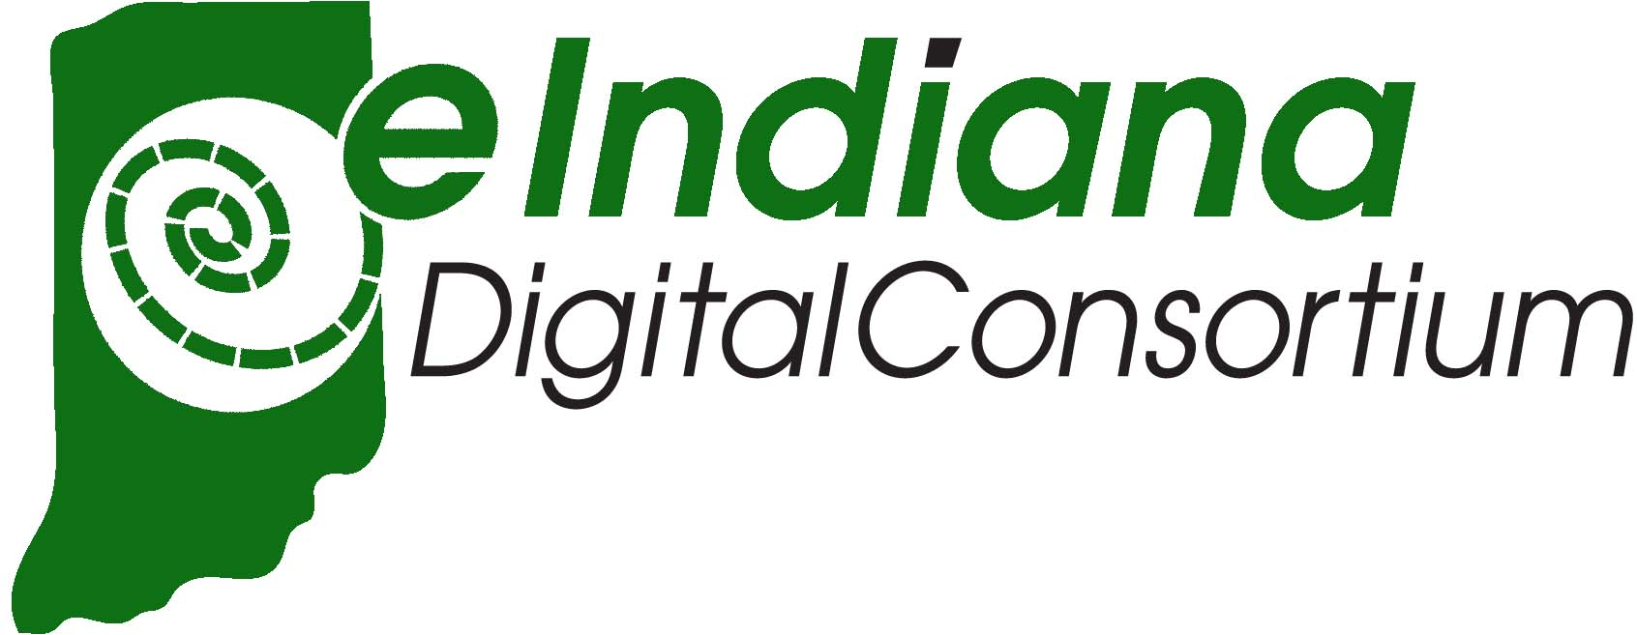

How to access eBooks from Coatesville – Clay Twp Public Library:
The eBooks collection is offered to our patrons who reside in Clay Township and to our patrons who have purchased a non-resident card. Loans will not be made to reciprocal borrowers or to patrons who are over the fine limit or who otherwise are in bad standing.
Click on the START page by either accessing the eBooks tab on our website http://coatesvillectpl.lib.in.us/ or by going directly to the link http://cidc.lib.overdrive.com/
Follow the instructions on the link. Search for our library, then enter your library card number and your password. (This is the password that was either assigned to you, or that you changed for ease of remembering it.) If you have problems with your password, please contact the library to have your password reset. (For your convenience, you can set the login to remember your information on your device or desktop for ease of use in the future.)
Search for books, streaming video, or periodicals.
**Set your borrowing time period in your ACCOUNT section. Since patrons are limited to 10 eBook checkouts and 5 periodical checkouts with no ability to return them early, it is best to check them out for the least amount of time possible. At the end of the loan period, the items will just disappear. Patrons do not have to initiate any actions to return the items.
Check out and enjoy this cool new collection!

